COMP7039 – Agile Processes

Assessment 2

AGILE RACERS

(GROUP LOGO)

Oscar Boix Ripolles R00257119

Dominik Kmita R00220247

Lisa Kavanagh R00215535

Omar Jundi R00217303

**End of Day 1 sprint**

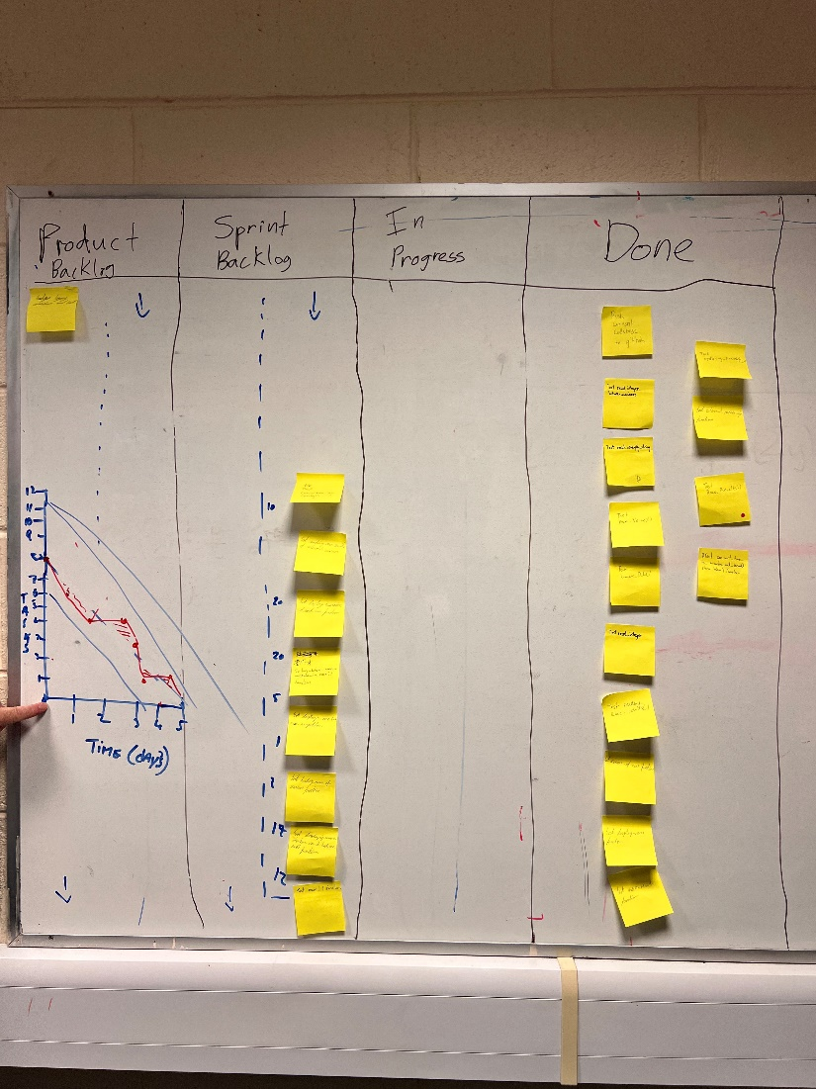

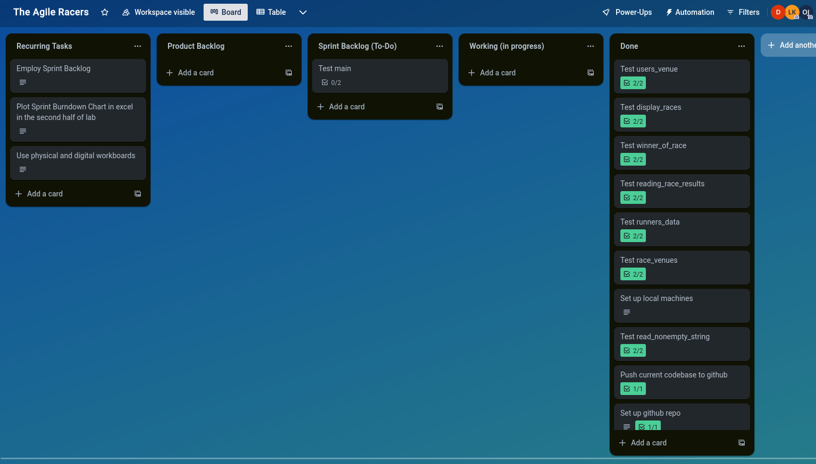

**Burndown chart**

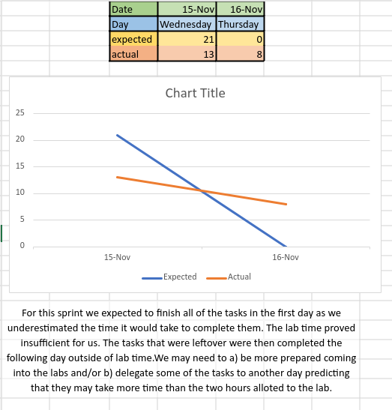

On day 1 we completed 13 tickets.

On day 2 we completed the remaining 8.